**DBMS ASSIGNMENT**

**NAME-RITAM HUDAIT**

**ROLL-1905797**

**Q.Create the following tables. The table name must be ended with your Roll No. (e.g. CUSTOMER_ROLLNO, BRANCH_ROLLNO etc...)**

**Ans;**

**customer**

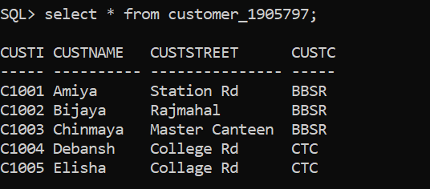

**account**

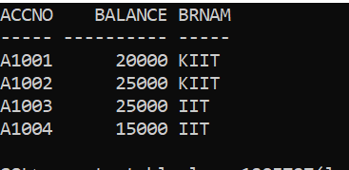

loan

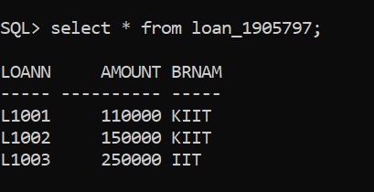

loan

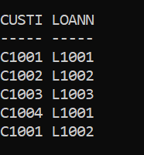

account

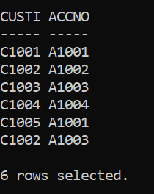

employee

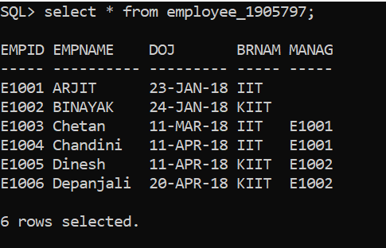

Employeesalary

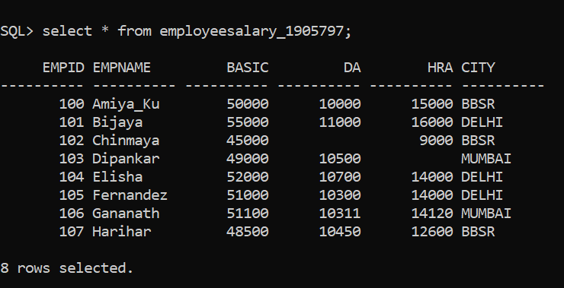

1.Display the custId, custName of all customer who have a loan along with their loanNo, loan mount and branch name.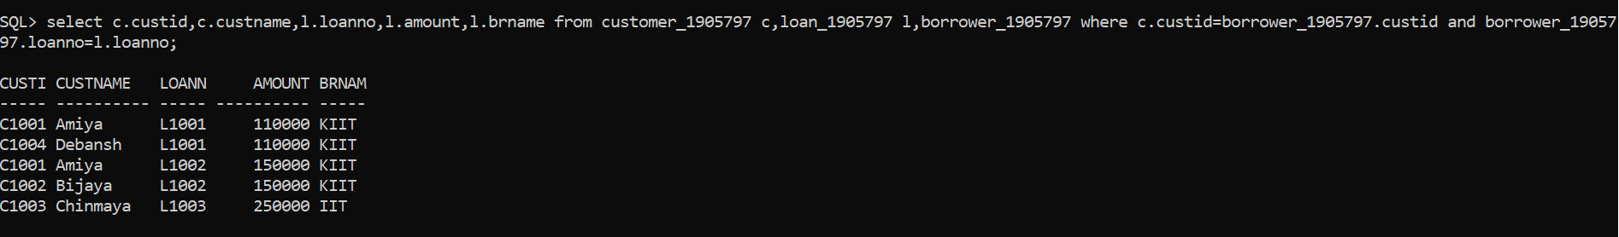

2.Display the custId, custName of all customer who have taken loan from KIIT branch with loan amount greater than 1,10,000/-.

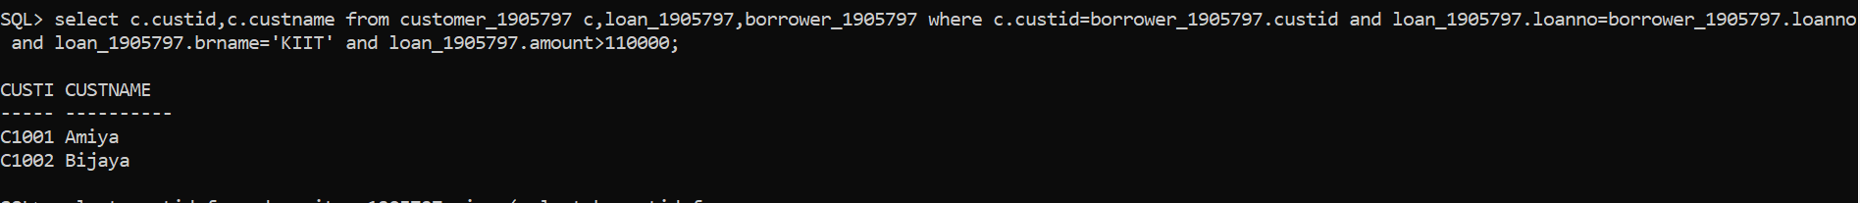

3.Find the custid of all customers who have an account but do not have any loan at the bank.



4.Find the custid of all customers who have a loan at the kiit branch but do not have an account at any branch of the bank.



5.Find the highest account balance of the bank (without using Max() fucntion). Use slef-join

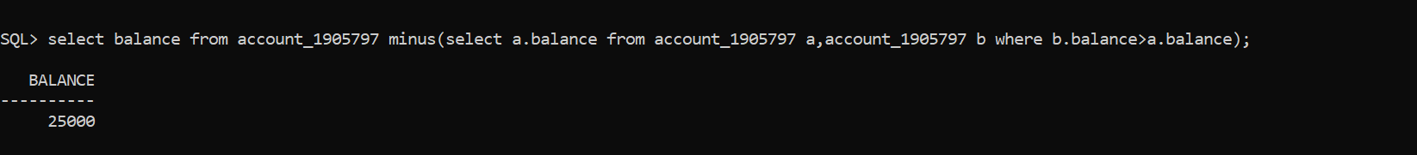

6.Find the custid of all customers who have an account, a loan, or both, from the bank

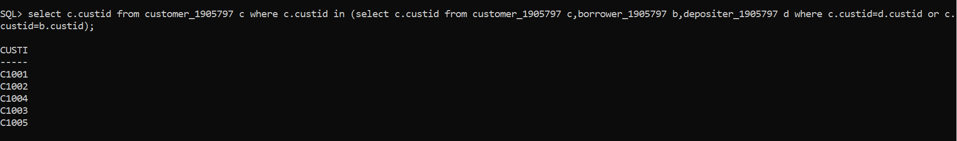

7.Find the custid of all customers who have an account BUT DO NOT HAVE ANY LOAN from the bank

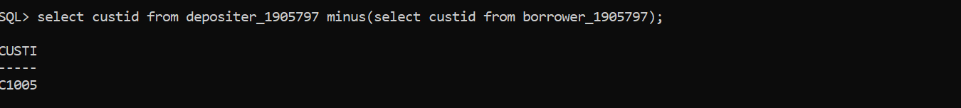

8.List the names of all employees who are working under “ARIJIT”

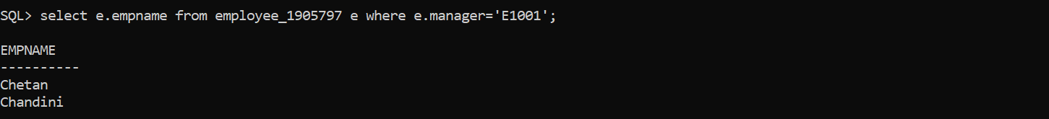

9.List the account number, balance, branch name of all accounts of the bank whose branch manager is ‘ARIJIT’??

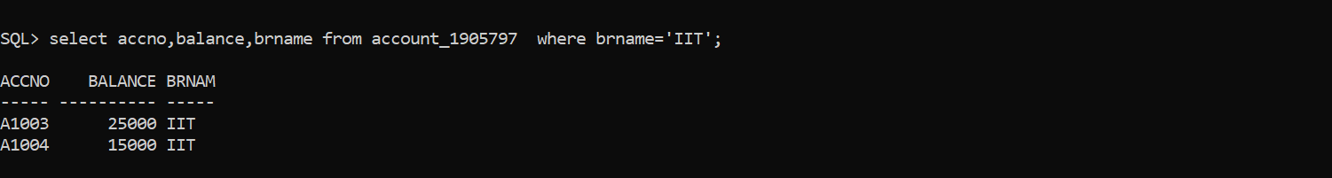

10.List the custId, custName of all customers who have an account in the bank (using sub-query)

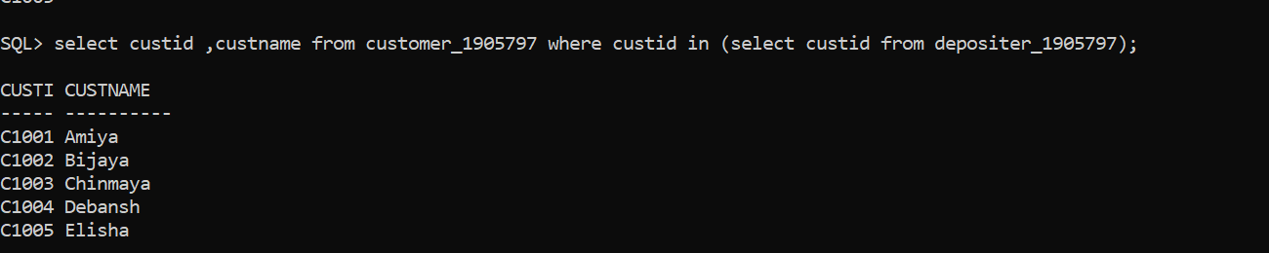

11.List the customer name of all customers who have an account in the KIIT branch. (using sub-query)

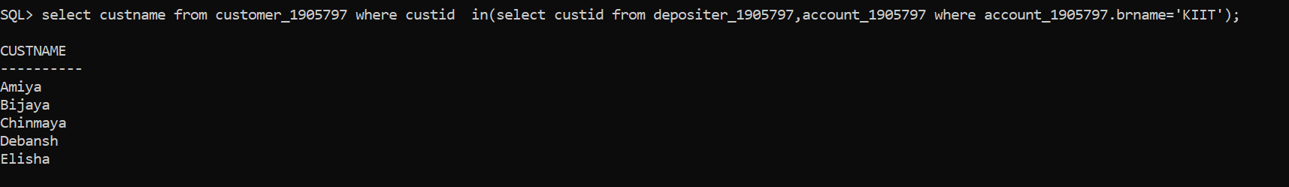

12.Create a table EMPLOYEEKIIT from EMPLOYEE who are working in KIIT branch. (using sub-query)



13.Using the sub-query, list the employee details of all employees who are staying in the city where Bijaya is staying??



14.Find all employees whose basic is less than the minimum average basic of cities.

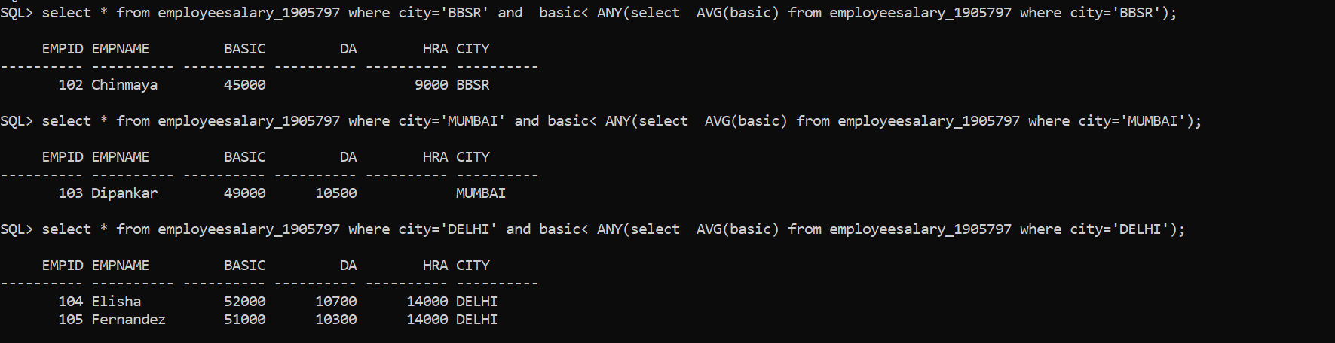

15.Find all employees whose basic is more than the maximum average basic of cities.

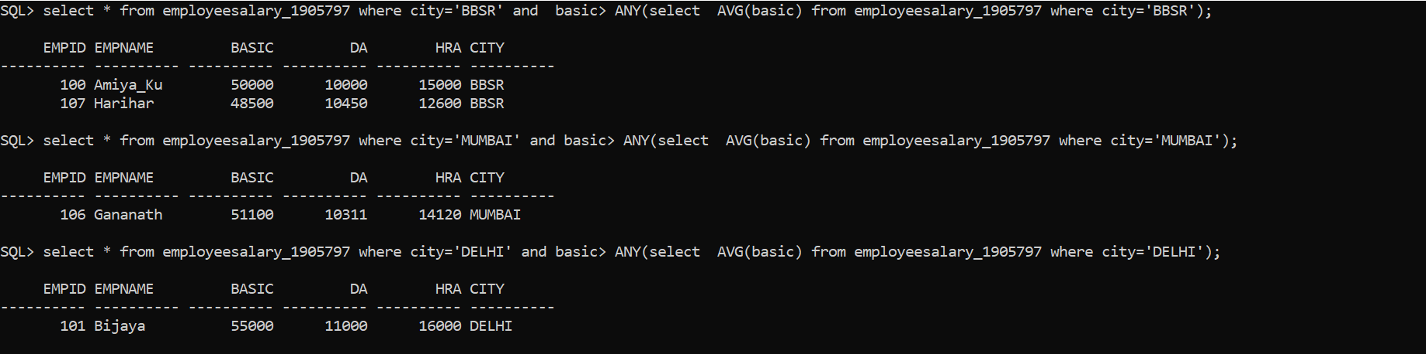

16.Display the average basic of all employees staying in BBSR city.



17.Display thelast record from the EmployeeSalary table.



18.Display the first 5 records from the EmployeeSalary table.

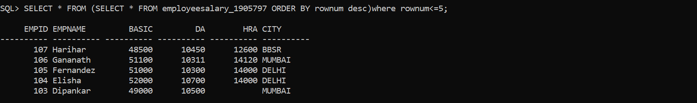

19. Display the last 5 records from the EmployeeSalary table.

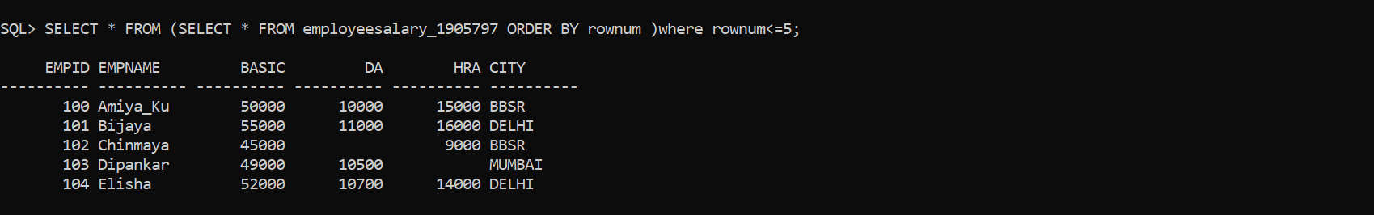

20.Find empid, empname and annual salary of all employees.

